**PT100 / HT100 NTC 100K Thermistor R/T Table**

Temperature (C), Ohm

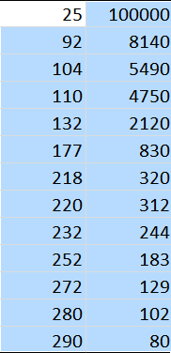



* 5 : 100K thermistor - ATC Semitec 104GT-2/104NT-4-R025H42G (Used in ParCan & J-Head) (4.7k pullup)

#define TEMP_SENSOR_0 5



temperature_control.hotend.thermistor Semitec



ATC Semitec 104GT-2

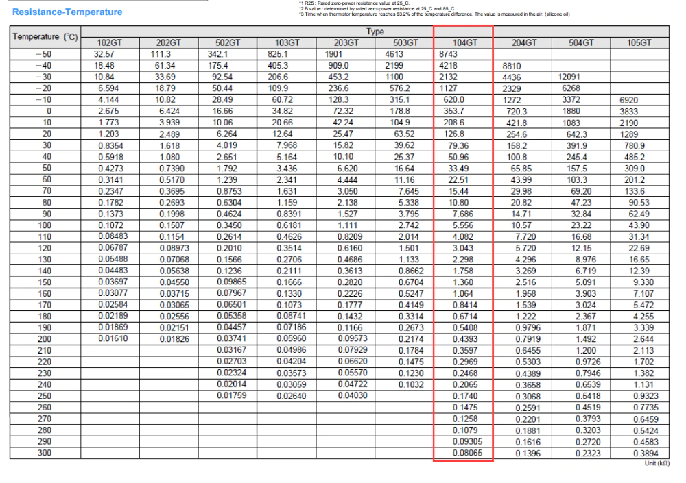

**HT 100K 300 Thermistor Table**

